DC MOTOR MODELING CODE
clc;
clear;
close all;

% DC motor parameters
R = 1; % Armature resistance (ohm)
L = 0.5; % Armature inductance (H)
J = 0.01; % Rotor inertia (kg.m^2)
B = 0.1; % Viscous friction (N.m.s)
Kt = 0.01; % Torque constant (N.m/A)
Kb = 0.01; % Back EMF constant (V/rad/s)
% Transfer function of DC motor (Speed / Voltage)
numerator = Kt;
denominator = [L*J (L*B + R*J) (R*B + Kt*Kb)];

motor_tf = tf(numerator, denominator)
% Step response of motor speed
figure;
step(motor_tf);
grid on;
title('DC Motor Speed Response');
xlabel('Time (seconds)');
ylabel('Speed (rad/sec)');
% Speed response for 5V input
figure;
step(5*motor_tf);
grid on;
title('DC Motor Speed Response for 5V Input');
% Time domain characteristics
info = stepinfo(motor_tf)

steady_state_speed = dcgain(motor_tf)
% State-space representation
A = [-R/L -Kb/L;
Kt/J -B/J];

B = [1/L;
0];

C = [0 1];
D = 0;

motor_ss = ss(A, B, C, D);

figure;
step(motor_ss);
grid on;
title('DC Motor State-Space Response');
% Time vector
t = linspace(0, 5, 200);

% Different input voltages
V = [1 3 5 7 10];

% Preallocate speed matrix
speed = zeros(length(V), length(t));

% Generate responses
for i = 1:length(V)
speed(i, :) = V(i) * step(motor_tf, t);
end

% Create surface plot
[T, Vgrid] = meshgrid(t, V);

figure;
surf(T, Vgrid, speed);
shading interp
xlabel('Time (seconds)');
ylabel('Input Voltage (V)');
zlabel('Motor Speed (rad/s)');
title('DC Motor Speed Response vs Time and Voltage');

OUTPUTS
motor_tf =

0.01
---------------------------
0.005 s^2 + 0.06 s + 0.1001

Continuous-time transfer function.
Model Properties
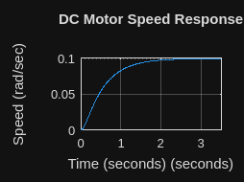
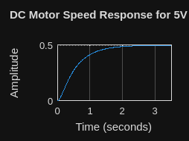
info = struct with fields:
RiseTime: 1.1351
TransientTime: 2.0652
SettlingTime: 2.0652
SettlingMin: 0.0899
SettlingMax: 0.0998
Overshoot: 0
Undershoot: 0
Peak: 0.0998
PeakTime: 3.6758
